(E4.3) A robotic arm and camera could be used to pick fruit, as shown in Figure E4.3(a). The camera is used to close the feedback loop to a microcomputer, which controls the arm [8,9]. The transfer function for the process is

1. Calculate the expected steady-state error of the gripper for a step command A as a function of K.
2. Name a possible disturbance signal for this system.

Ans.

1. The tracking error, E(s) = R(s) − Y (s), is given by

The steady-state error (computed using the ﬁnal value theorem) is

1. A disturbance would be the wind shaking the robot arm.

(E4.9) Submersibles with clear plastic hulls have the potential to revolutionize underwater leisure. One small submersible vehicle has a depth-control system as illustrated in Figure E4.9.

1. Determine the closed-loop transfer function T(s) = Y(s)/R(s).
2. Determine the sensitivity and .
3. Determine the steady-state error due to a disturbance .
4. Calculate the response y(t) for a step input R(s) = 1/s when K = K2 = l and l < K1 < 10. Select K1 for the fastest response.

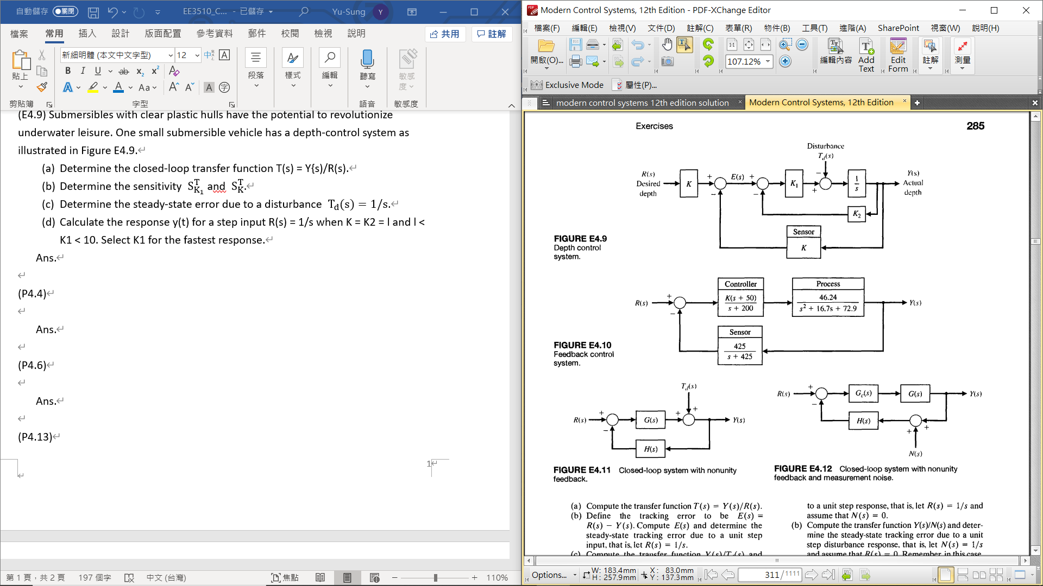

Ans.

where u(t) is the unit step function. Therefore, select K1 = 10 for the fastest response.

(P4.4) A control system has two forward paths, as shown in Figure P4.4.

1. Determine the overall transfer function T(s) = Y(s)/R(s).
2. Calculate the sensitivity, , using Equation (4.16).
3. Does the sensitivity depend on U(s) or M(s)?

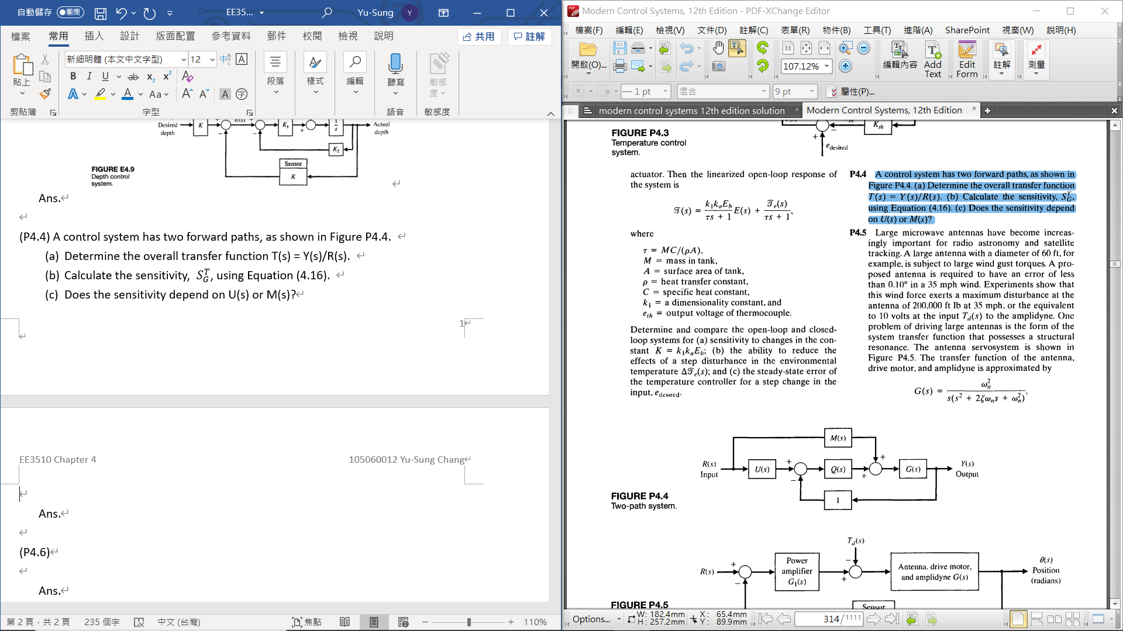

Ans.

1. The sensitivity does not depend upon U(s) or M(s).

(P4.6) An automatic speed control system will be necessary for passenger cars traveling on the automatic highways of the future. A model of a feedback speed

control system for a standard vehicle is shown in Figure P4.6. The load disturbance due to a percent gradeis also shown. The engine gain Kt. varies within the range of 10 to 1000 for various models of automobiles. The engine time constant is 20 seconds

1. Determine the sensitivity of the system to changes in the engine gain Ke.
2. Determine the effect of the load torque on the speed.
3. Determine the constant percent gradefor which the vehicle stalls (velocity V(s) = 0) in terms of the gain factors. Note that since the grade is constant, the steady-state solution is sufficient. Assume that R(s) = 30/s km/hr and that» 1. When= 2, what percent grade would cause the automobile to stall?

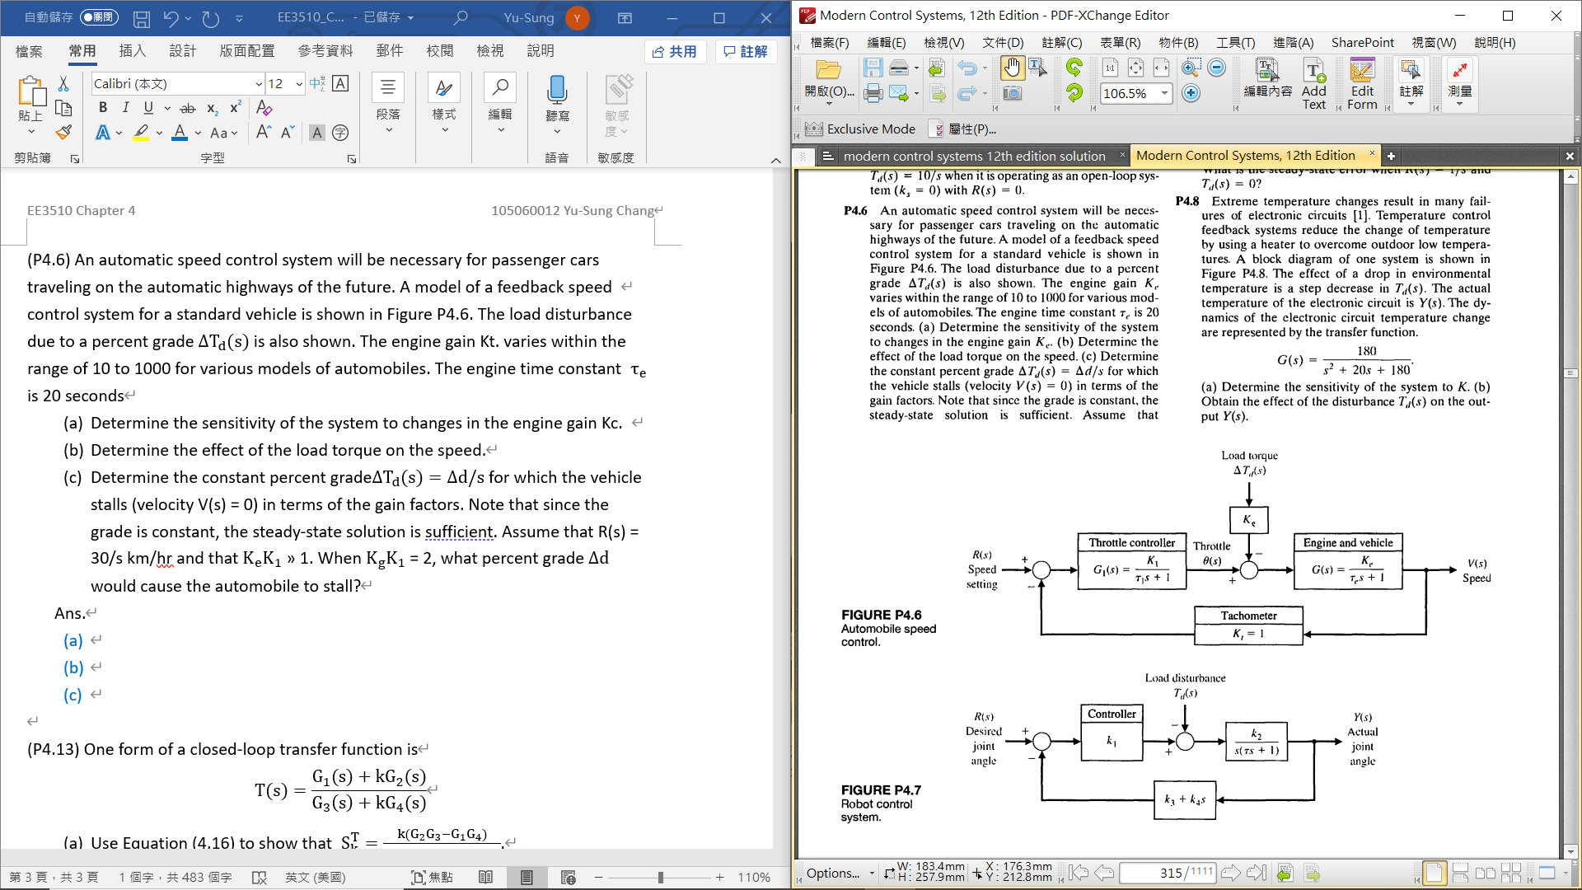

Ans.

1. . When the car stalls,

* Using value theorem

* When

(P4.13) One form of a closed-loop transfer function is

1. Use Equation (4.16) to show that
2. Determine the sensitivity of the system shown in Figure P4.13, using the equation verified in part (a).

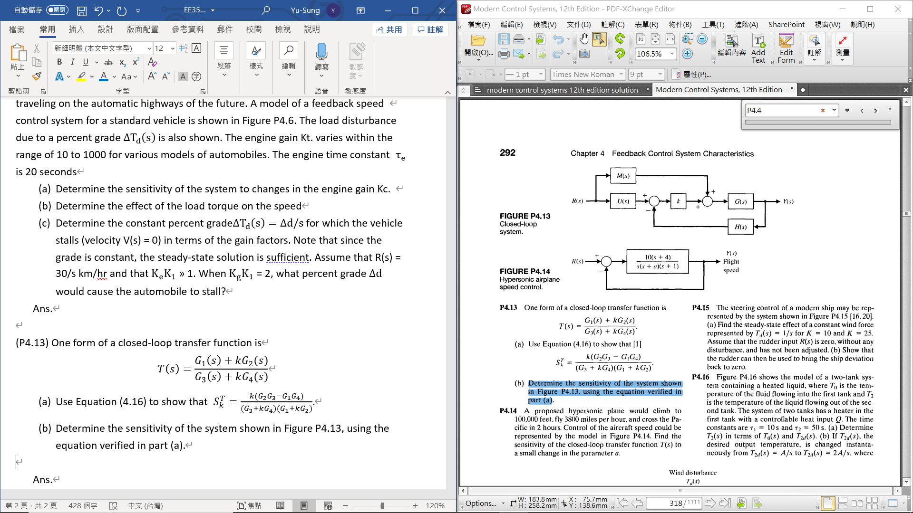

Ans.